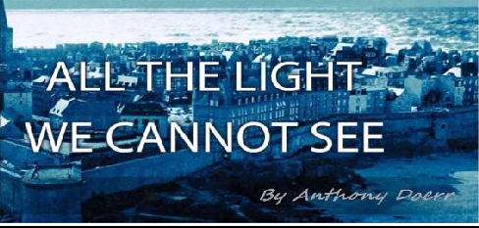
Assignment One: The Novel

Significance of Title

Briefly discuss the significance of the title. Is it an allusion to an event or another work? How is it thematically connected to the body of the work? Does it have multiple meanings?

Setting

Describe the time and place in which the action occurs. How is it related to the time period in which the work was written? What is significant about the setting? How is the setting connected to thematic concerns?

Plot

Briefly summarize the plot (several paragraphs), using standard formats of basic plot structure as they may apply: exposition, initial incident, rising action, turning point, climax, falling action, denouement (resolution). Discuss conflict and any other devices that significantly impact plot.

Point of View

From what perspective is the story told? How does point of view affect your understanding of the work? How does the choice of narrator impact the theme(s) of the work?

Characterization

Identify the top five characters in order of importance (starting with protagonist and antagonist) and describe them and their role in the work. Discuss any characters that have a significant impact on the work.

Theme

Identify and discuss any important messages and ideas the author communicates in the work. Remember that themes are important ideas conveyed. In order for an idea to be important (and, therefore, thematic) it must be repeated.

Assignment Two: Poetry
http://www.loc.gov/poetry/180 Billy Collins
Go to the above website and spend some time reading several of the 180 poems listed. Choose any five poems, print them out, and bring them the first day of class. You will write an in-class essay about your chosen poems during the first week of school.

